Fireworks Safety Messaging Toolkit
Fireworks are dangerous and illegal in the City of San José

KEY MESSAGES
- All types of fireworks, even those labeled 'safe and sane' are illegal in San José and most of Santa Clara County.
- Snap, Click, and Report illegal fireworks activity online at sanjoseca.gov/fireworks or by calling 3-1-1. If able to safely capture photos/videos of fireworks being used, snap one to include with the online report.
- Fireworks reports may not result in emergency resources being immediate dispatched, however, all reports will be reviewed and if sufficient information and evidence is provided, the City’s Code Enforcement Division will issue a warning letter or citation.
- San José fines for illegal fireworks use are now among the highest in the Bay Area. Fines have increased and now start at $1,000 and escalate to $2,000 and $3,000 for a 2nd and 3rd violation.
- San José’s Social Host Ordinance has been expanded. Property owners and those hosting gatherings where fireworks are used will be held liable for fireworks fines as well as emergency response costs resulting from the use of illegal fireworks.
- We are in wildfire season and San José is facing drought conditions; one spark from an illegal firework can quickly start a devastating fire in our community.
- Be a considerate neighbor. Consider that more pets are lost on the 4th of July than any other day of the year, partly due to the noise caused by fireworks. Fireworks can also be a major source of stress, especially for veterans or others who suffer from Posttraumatic Stress Disorder (PTSD).
STATISTICS
The National Fire Protection Association reports that fireworks start an average of 19,500 fires per year, 59% of which were reported as brush, grass or forest fires. These fires caused an average of five deaths, 46 civilian injuries, and an average of $105 million in direct property damage.
During the 2020 Fourth of July reporting period, San José Fire Department (SJFD) responded to over 30 preventable fireworks-related fires. This includes structure fires, vegetation fires, outside/rubbish fires and vehicle fires.
San José Fire Department responded to 54 fireworks-related fires during the 2020 Fourth of July reporting period (June 1, 2020 – July 12, 2020). This includes 9 structure fires, 34 vegetation fires, 8 outside/rubbish fires and 3 vehicle fires. Firefighters also responded to 2 fireworks-related injuries during this period.

NEWSLETTER COPY
Headline: Fed up with fireworks? Snap, click, and report online.
Body:
San José was overwhelmed by illegal fireworks last year, and 2021 is off to another unfortunate start with nightly fireworks already occurring. We need your help to stop the dangerous and disruptive use of illegal fireworks in our community this wildfire season.
REPORTING
Report illegal fireworks online at www.sanjoseca.gov/fireworks or call 3-1-1. When filing an online report, provide as much detail as possible and include a photo or video if you can safely snap images of the activity. Fireworks reports may not result in emergency resources being immediate dispatched, however, all reports will be reviewed and if sufficient information and evidence is provided, the City’s Code Enforcement Division will issue a warning letter or citation.
FINES & SOCIAL HOST ORDINANCE UPDATES
Fines for illegal fireworks now begin at $1,000 and escalate to $2,000 and $3,000 for a 2nd and 3rd violation. Fines for the sale of fireworks can reach $50,000 plus jail time, depending on the quantity. San José’s Social Host Ordinance has also been updated and expands liability to the property owner and social host, or person hosting a gathering where fireworks are used. The social host and property owner will be held liable for illegal fireworks fines as well as any emergency response costs resulting from the use of illegal fireworks.
IT’S NOT WORTH IT
Considering the extreme danger of wildfires, injury and property damage, the financial impacts of fines, or the trauma experienced by pets and veterans due to illegal fireworks use – it’s just not worth it. Please celebrate safely and without the use of illegal fireworks.
STATISTICS
The National Fire Protection Association reports that fireworks start an average of 19,500 fires per year, 59% of which were reported as brush, grass or forest fires. These fires caused an average of five deaths, 46 civilian injuries, and an average of $105 million in direct property damage. San José Fire Department responded to 54 fireworks-related fires during the 2020 Fourth of July reporting period. This includes 9 structure fires, 34 vegetation fires, 8 outside/rubbish fires and 3 vehicle fires. Drought stressed vegetation puts San José at extreme risk of wildfires this season – all it takes is one spark to have devastating consequences for our community.
Please help avoid fires, injuries, and damage caused by illegal fireworks use this Fourth of July. As always, if you observe an active fire or experience a medical emergency, please call 9-1-1.

SOCIAL MEDIA MESSAGING & GRAPHICS
(ENGLISH/SPANISH/VIETNAMESE)

1. FED UP WITH FIREWORKS?
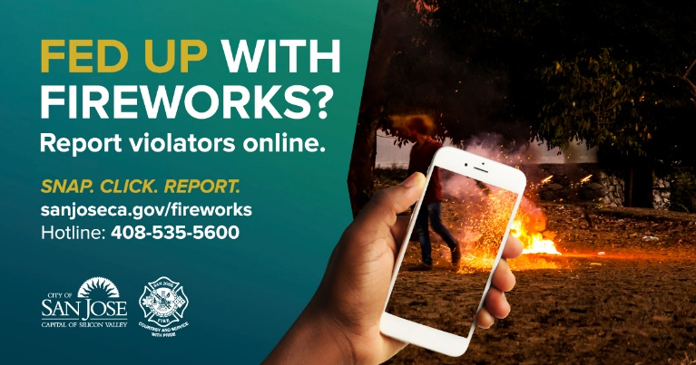
Download Graphics:
- Facebook - English, Spanish, Vietnamese
- Twitter - English, Spanish, Vietnamese
- Instagram - English, Spanish, Vietnamese
Sample Message:
- English: Fed up with fireworks? Report illegal firework activity online at www.sanjoseca.gov/fireworks. Snap a picture and complete the report fully so the @CityofSanJose can take action to cite violators.
- Spanish: ¿Harto de los fuegos artificiales? Denuncie la actividad ilegal de fuegos artificiales en línea en www.sanjoseca.gov/fireworks. Tome una foto y complete el informe para que @CityofSanJose pueda tomar medidas para citar a los infractores.
- Vietnamese: Mệt mỏi với pháo hoa? Báo cáo hoạt động bắn pháo hoa bất hợp pháp trực tuyến tại www.sanjoseca.gov/fireworks. Chụp ảnh và hoàn thành báo cáo đầy đủ để @CityofSanJose có thể phạt những người vi phạm.

2. FED UP WITH FIREWORKS?
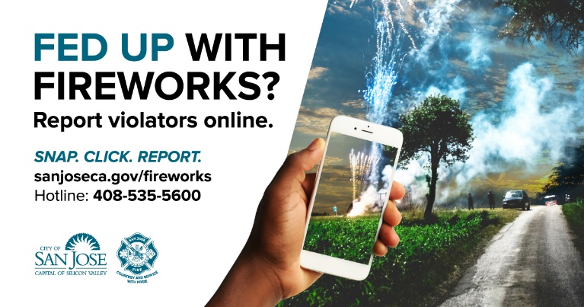
Download Graphics:
- Facebook - English, Spanish, Vietnamese
- Twitter - English, Spanish, Vietnamese
- Instagram - English, Spanish, Vietnamese
Sample Message:
- English: All fireworks are dangerous and illegal to own, use or sell in the @CityofSanJose. Help keep #SanJose safe this 4th of July – snap, click and report illegal firework use online at www.sanjoseca.gov/fireworks.
- Spanish: Todos los fuegos artificiales son peligrosos e ilegales para poseer, usar o vender en @CityofSanJose. Ayude a mantener #SanJose seguro este 4 de Julio – Tome una foto, haga clic y reporte en línea el uso ilegal de fuegos artificiales en www.sanjoseca.gov/fireworks.
- Vietnamese: Tất cả pháo hoa đều nguy hiểm và bất hợp pháp khi sở hữu, sử dụng hoặc bán trong @CityofSanJose. Hãy giúp giữ #SanJose an toàn vào ngày 4 tháng 7 này - chụp, nhấp và báo cáo việc sử dụng pháo hoa bất hợp pháp trực tuyến tại www.sanjoseca.gov/fireworks.

3. IT’s not worth it
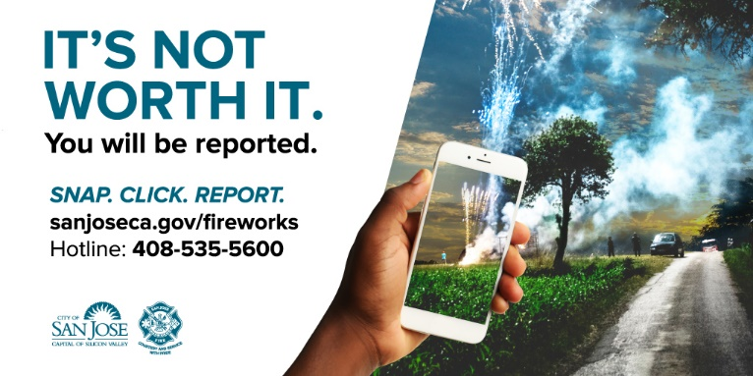
Download Graphics:
- Facebook - English, Spanish, Vietnamese
- Twitter - English, Spanish, Vietnamese
- Instagram - English, Spanish, Vietnamese
Sample Message:
- English: Not only are fireworks dangerous, they’re illegal and you can be fined up to $3,000 for using them in #SanJose. It’s not worth it! Report illegal firework activity this 4th of July – snap a picture and file a report online at www.sanjoseca.gov/fireworks.
- Spanish: Los fuegos artificiales no solo son peligrosos sino que también son ilegales y puede recibir una multa de hasta $3,000 por usarlos en #SanJose. ¡No vale la pena! Reporte actividad ilegal de fuegos artificiales: tome una foto y presente un informe en línea: www.sanjoseca.gov/fireworks
- Vietnamese: Pháo hoa không chỉ nguy hiểm, chúng còn bất hợp pháp và bạn có thể bị phạt tới $3000 vì sử dụng chúng trong #SanJose. Nó không đáng! Báo cáo hoạt động bắn pháo hoa bất hợp pháp vào ngày 4 tháng 7 này - chỉ cần chụp ảnh và báo cáo trực tuyến tại www.sanjoseca.gov/fireworks.

4. IT’s not worth it – Social Host and FInes Emphasis
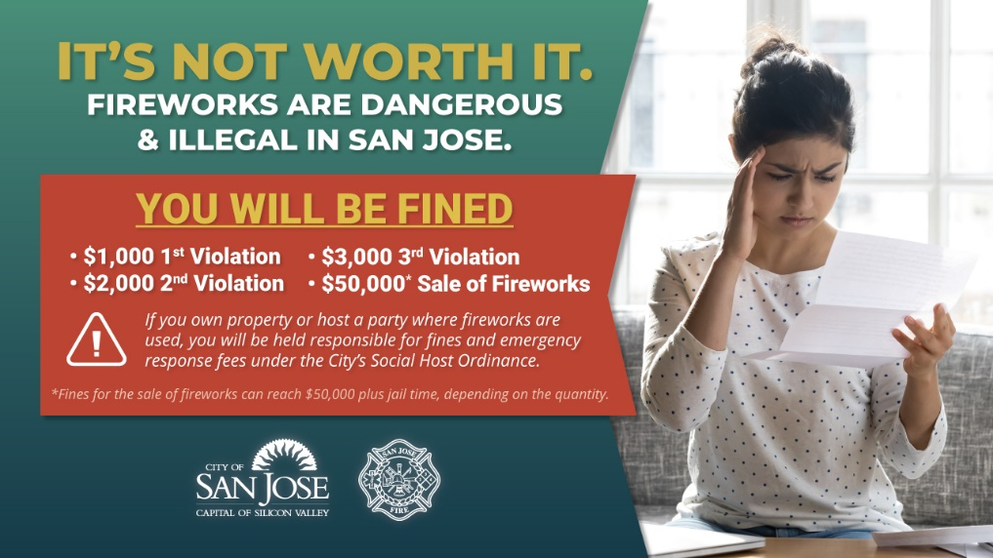
Download Graphics: English, Spanish, Vietnamese
- English: It’s not worth it. If you own property or host a party where fireworks are used, you will be held responsible for fines and emergency response fees under the City’s Social Host Ordinance. Report illegal firework activity online at www.sanjoseca.gov/fireworks.
- Spanish: No vale la pena. Si eres dueño de una propiedad o organiza una fiesta en donde se utilizan fuegos artificiales, serás responsable de las multas y las tarifas de respuesta de emergencia según la Ordenanza de Anfitrión Social de la Ciudad. Denuncie la actividad ilegal de fuegos artificiales en línea en www.sanjoseca.gov/fireworks.
- Vietnamese: Điều đó không đáng. Nếu quí vị là chủ sở hữu hoặc người tổ chức một bữa tiệc có sử dụng pháo hoa, quí vị sẽ phải chịu trách nhiệm về tiền phạt và phí ứng cứu khẩn cấp theo Sắc lệnh Xã hội của Thành phố. Báo cáo hoạt động bắn pháo hoa bất hợp pháp trực tuyến tại www.sanjoseca.gov/fireworks.
ALTERNATIVE ACTIVITIES & GRAPHICS
With many community events continuing to be impacted by the COVID-19 pandemic, community members in search of safe and fun alternative activities may consider the following:
- Go camping in your own backyard: Set up a tent and enjoy a night under the stars
- Have a dance off: Light the night with glow sticks and dance to your favorite tunes
- Pack a picnic and visit a local park: Remember to follow all posted signage
- Make a festive snack or craft: Enjoy a patriotic DIY project with the kids
- Watch a movie under the stars: Check YouTube to learn how to make a projector using your smart phone
- Create a waterpark at home: Set up sprinklers and a splash pool filled with water balloons
- Plan an online watch party: Enjoy a patriotic firework show online
- Have a sports-a-thon: Plan a friendly competition with members of your household
- Fly a kite: Add to the fun and build your own kite
- Go for a bike ride: Enjoy a bike ride around your neighborhood or local park

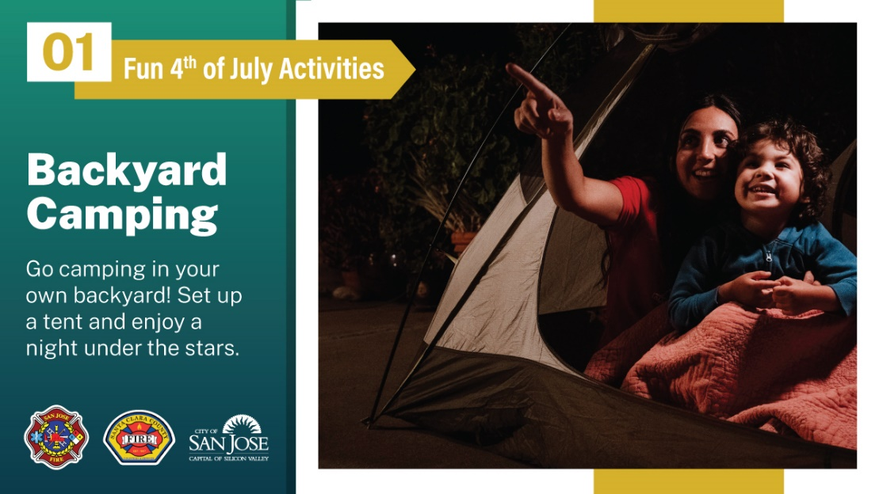
(Right click image to save/download)
